H.T No
Regulations:
A15

Sreenidhi Institute of Science and Technology
(An Autonomous Institution)
Code No: 5H315 Date: 24-Jan-2025 (FN)

B.Tech II-Year I- Semester External Examination, January - 2025 (Supplementary)
Engineering Mathematics-III (Common to All Except BT)

Time: 3 Hours Max.Marks:75

Note: a) No additional answer sheets will be provided.
b) All sub-parts of a question must be answered at one place only, otherwise it will not be valued.
c) Missing data can be assumed suitably.

Bloom's Cognitive Levels of Learning (BCLL)

Remember | L1 | Apply | L3 | Evaluate | L5
Understand | L2 | Analyze | L4 | Create | L6

Part - A Max.Marks:25
Answer all QUESTIONS

 |  | BCLL | CO(s) | Marks
1 | Find the interval where the equation 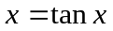 has a positive real root, if possible. | L1 | CO1 | [2M]
2 | Operate 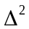 for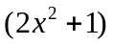. | L1 | CO2 | [2M]
3 | Find, using Euler’s method . | L3 | CO3 | [2M]
4 | Define 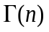for any integer n. | L2 | CO4 | [2M]
5 | Find the value of such that 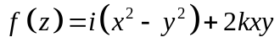 is an entire function | L4 | CO5 | [2M]
6 | Explain the transformation ‘Inversion’. | L3 | CO6 | [3M]
7 | Write the Simpson’s 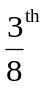rule | L2 | CO2 | [3M]
8 | Show that 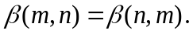 | L1 | CO3 | [3M]
9 | Find the residue of 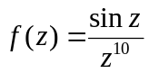 at  | L3 | CO5 | [3M]
10 | Explain forward and backward differences. | L5 | CO4 | [3M]
Part – B Max.Marks:50
ANSWER ANY FIVE QUESTIONS. EACH QUESTION CARRIES 10 MARKS.

 |  |  | BCLL | CO(s) | Marks
11. | a) | Find an approximate real root of 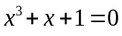 by the Bisection method, correct to four decimal places | L2 | CO1 | [5M]
 | b) | Evaluate 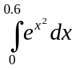 by using (i) Trapezoidal rule (ii).Simpson’s 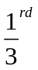rule by taking 6 number of subintervals. | L3 | CO1 | [5M]
12. | a) | Construct Newton’s forward interpolating polynomial for the following data | L1 | CO2 | [5M]
  x | 4 | 6 | 8 | 10
  f(x) | 1 | 3 | 8 | 16
 | b) | Using Lagrange’s interpolation find the polynomial f(x) for the following data | L1 | CO2 | [5M]
  X | 0 | 1 | 2 | 5
  f(x) | 2 | 3 | 12 | 147
13. | a) | Find 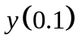 from the initial value problem 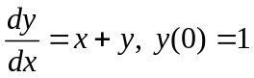 by Taylor’s series method. | L3 | CO3 | [5M]
 | b) | Find from the initial value problem 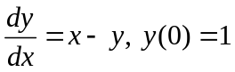 in steps of 0.1 by Runge- Kutta method of fourth order. | L3 | CO3 | [5M]
14. | a) | Prove that the relation 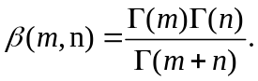 | L5 | CO4 | [5M]
 | b) | Show that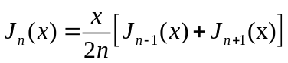 . | L4 | CO4 | [5M]
15. | a) | Find an analytic function whose real part is 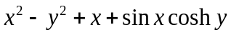. | L3 | CO5 | [5M]
 | b) | Find the Laurent’s series expansion of 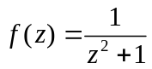in the regions  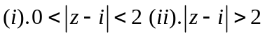. | L3 | CO5 | [5M]
16. | a) | Find the bilinear transformation that map 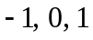 onto 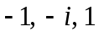 respectively. | L2 | CO6 | [5M]
 | b) | Show that the transformation 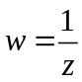 maps a circle to a circle or a straight line if the former goes through the origin. | L1 | CO6 | [5M]
17. | a) | Find the Lagrange interpolating polynomial from the data  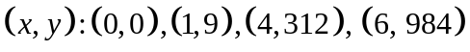 and hence find 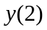. | L2 | CO1 | [5M]
 | b) | 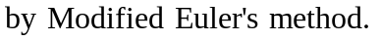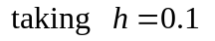 | L3 | CO2 | [5M]
18. | a) | Evaluate 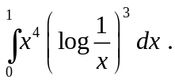 | L2 | CO4 | [3M]
 | b) | Find poles and residues of the function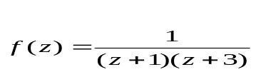. | L3 | CO5 | [4M]
 | c) | Define conformal mapping and bilinear transformation. | L1 | CO6 | [3M]

-- 00 -- 00 –

